

**KIET Group of Institutions, Ghaziabad**

***COMPUTER SCIENCE AND INFORMATION TECHNOLOGY***

**PROJECT BASED LEARNING**

**on**

**PHONEBOOK MANAGEMENT SYSTEM**

**SUBJECT: DATA STRUCTURES USING C LAB**

**(KCS-301)**

**Submitted By:**

**RUDRANSH SRIVASTAVA – 2100290110135**

**UTSAH SHANKER - 2100290110178**

**VANSH SHARMA - 2100290110185**

**ACKNOWLEDGEMENT**

## I’ve got this golden opportunity to express my kind gratitude and sincere thanks to my subject faculty **“Mr. Vinay Kumar”**, Computer Science and Information Technology Department, **KIET GROUP OF INSTITUTIONS** for their kind support and necessary counselling in the preparation of this project report. I’m also indebted to every person responsible for the making up of this project directly or indirectly.

I must also acknowledge or deep debt of gratitude each one of my colleagues who led this project come out in the way it is. It’s my hard work and untiring sincere efforts and cooperation to bring out the project work. Last but not the least, I would like to thank my parents for their sound counselling and cheerful support. They have always inspired us and kept our spirit up.

**Aim:** To make a phonebook management system

**Objective:** To use to doubly linked list, heap and tree data structures to achieve the aim.

**Abstract:** The primary features that make up the main menu of this Phonebook program include adding new records, listing them, altering and updating them, searching for stored contacts, and deleting phonebook data.

When adding a record to the Phonebook, personal information such as name, gender, father's name, phone number, citizenship number, email, and address is requested. Modifying, listing, searching for, and removing these records is then possible**.**

**Basic principle:** The file handling method and data structure are utilized for storing data and performing the basic phonebook operations in this application**.**

**Methodology:** To use data structure to store phonebook data and display data.

# Flowchart:

# CODING IMPLEMENTATION:

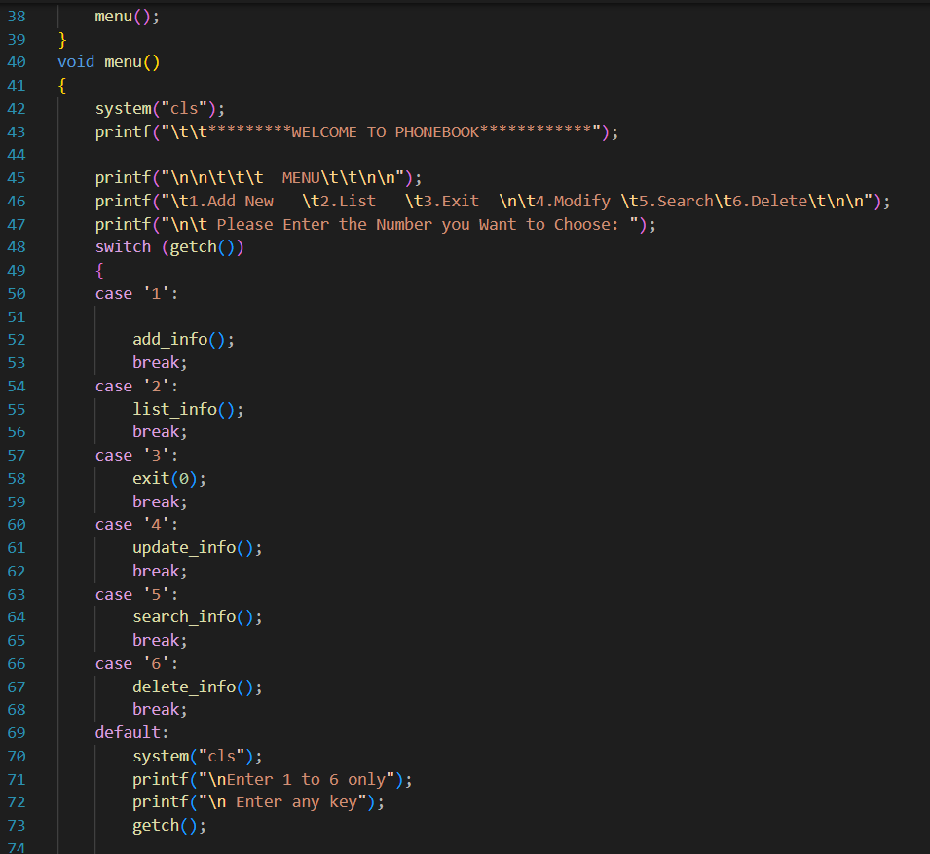

# RESULT / OUTPUT

**TIME COMPLEXITY:** O(n)

# SPACE COMPLEXITY: O(1)